Introduction to
SQL Server 2012

Objectives
At the end of this session, the student will be able to:
  - Use the SQL Server Management Studio.
  - Attach and detach the AdventureWorks2012 sample database.
  - Backup and restore database.
Part I - 90 minutes
  - Exercise 1: Launch SQL Server Management Studio
- Opening SQL Server Management Studio
- Click Start → All Programs→ Microsoft SQL Server 2012→ SQL Server Management Studio.
- In the Connect to Server dialog box, select the Server type as Database Engine. Type the Server name.
- Select either Windows Authentication or SQL Server Authentication, provide the required Login and Password, and click Connect.
Figure 1.1 shows the Connect to Server dialog box.
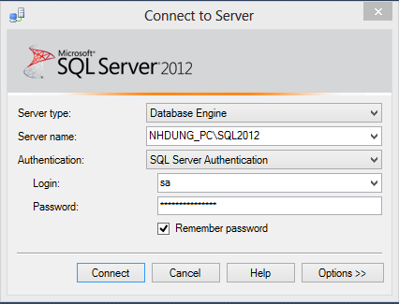
Figure 1.1 - Connect to Server dialog box
After connecting SQL Server, the Microsoft SQL Server Management Studio window is displayed as shown in Figure 1.2
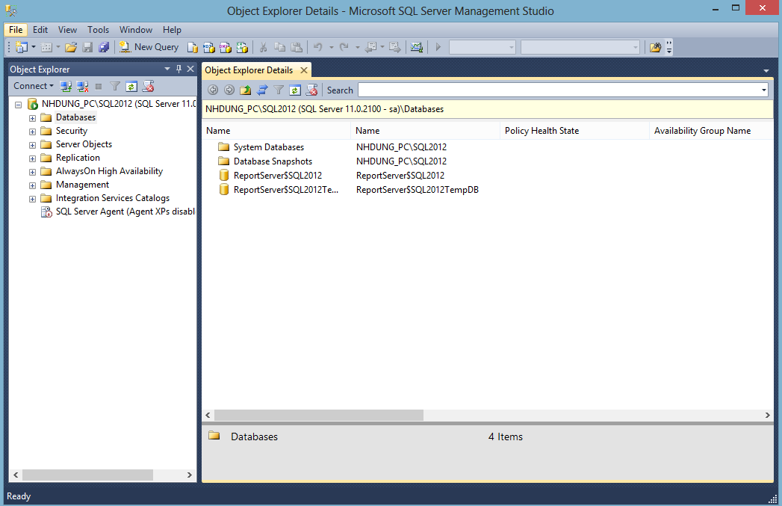
Figure 1.2 - SQL Server Management Studio
SQL Server Management Studio presents information in various windows dedicated to specific types of information. Object Explorer displays all the database object of the server in a tree structure.
Object Explorer
The toolbar at the top of the Object Explorer window has seven buttons. The Connect button on the left connects a server instance to Object Explorer. Connect Object Explorer button is the same Connect button. The Disconnect button disconnects a server instance from Object Explorer. The Stop button stops the current Object Explorer action. The Refresh button refreshes a tree node. The Filter button returns a subset of items in a folder and the Show Policy Health State for all node button will help track down the violated policies.
Connect to another SQL Server instance
- Click Connect button from Object Explorer for a list of possible connections, select the Database Engine option as shown in Figure 1.3.
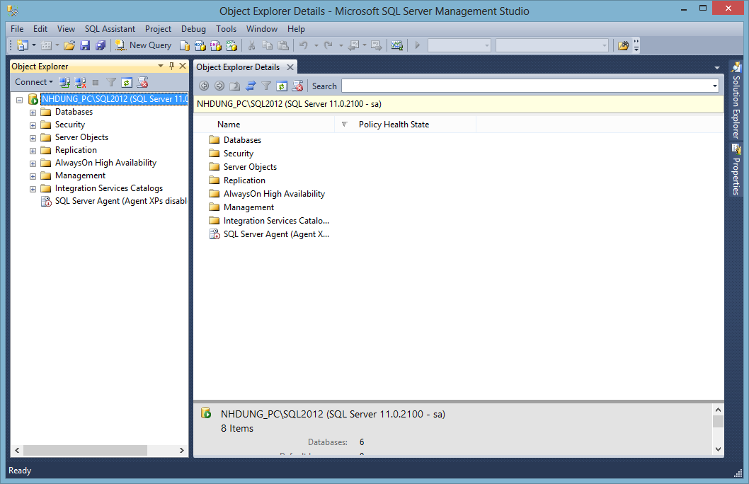
Figure 1.3 - Connect button in Object Explorer
The Connection to Server dialog opens
- Type the instance name of SQL Server and the required information. The new SQL Server instance is connected as shown in Figure 1.4.
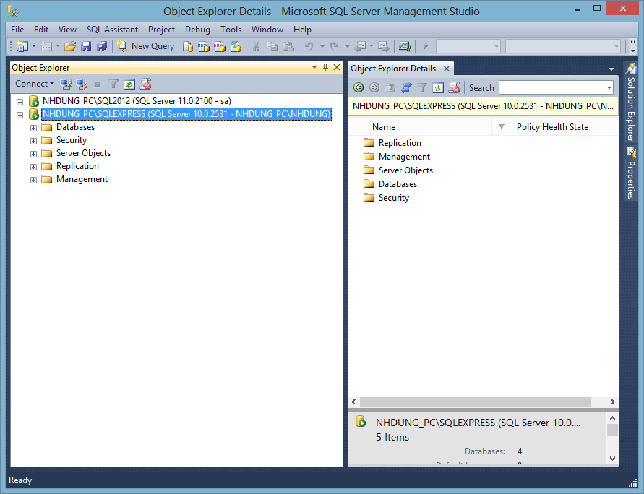
Figure 1.4 - New Server instance in Object Explorer
Database node in Object Explorer
The database node in Object Explorer contains system database, database snapshot, and user database. Figure 1.5 shown Database node and the objects present in it
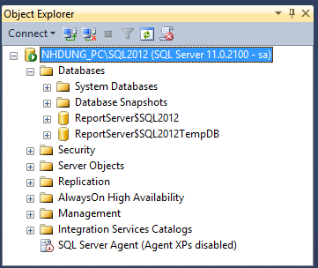
Figure 1.5 - Object Explorer Database node
Launch Query Editor
Query Editor is a code pane in SQL Server Management Studio that is used to enter SQL statements. The steps to launch query editor and execute and SQL statement are given below:
- Click File → New → Query with Current Connection form the menu. The Query Editor window is displayed as shown in Figure 1.6.
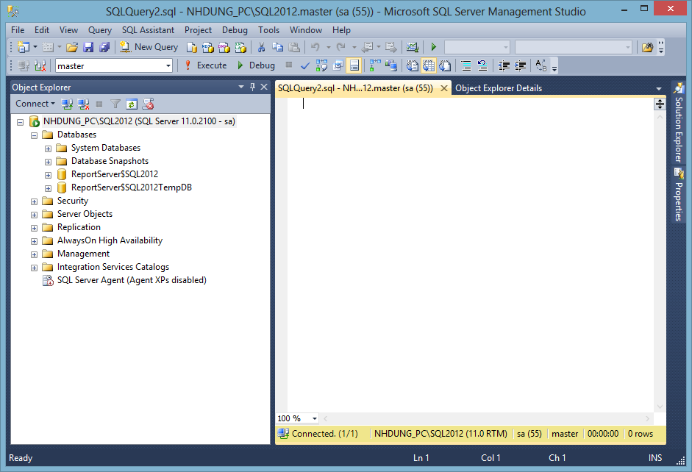
Figure 1.6 - Query Editor Window
Type below SQL statement in Editor:
SELECT * FROM MSreplication_options

- Click Query → Execute from the main menu to execute SQL statements. The result is displayed as shown in Figure 1.7
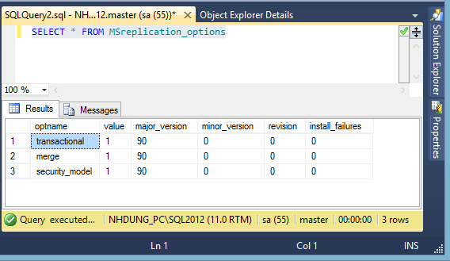
Figure 1.7 - Execute SQL Statement in Query Editor
  - Exercise 2: Attaching a database
This exercise will demonstrate attaching the AdventureWorks2012 sample database that provided by Microsoft.
A database can be attached using the "Attach Database" option in the SQL Server Management Studio, Object Explorer.
Attaching a database means making all the database files in that database available to SQL Server. The user has to specify only the primary file when attaching the database. SQL Server will read the information in the primary file and attach all other associated files of the database. The steps to attach the AdventureWorks2012 database are given below:
Note: You must copy two files (AdventureWorks2012_Data.mdf and AdventureWorks2012_log.ldf) into DATA folder of SQL Server 2012.
- Right click the Database folder from Object Explorer window, and click Attach. The Attach Database dialog box opens as shown in Figure 1.8
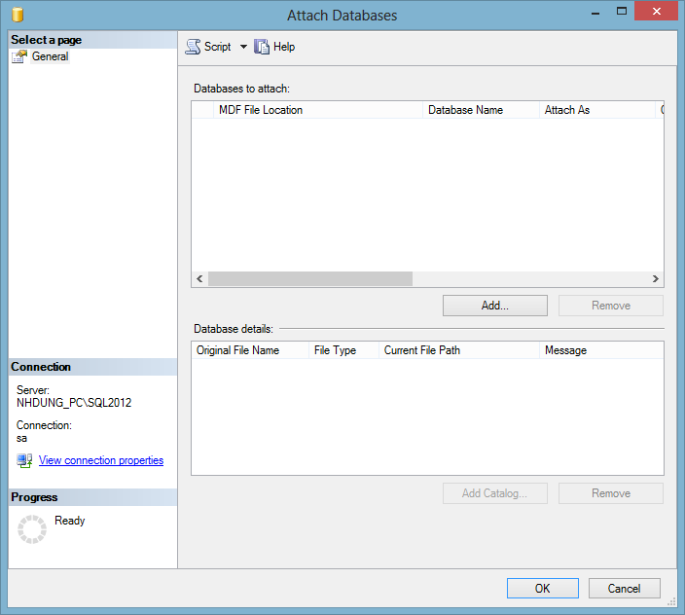
Figure 1.8 - Attach databases Dialog box
- Click Add. The Locate Database Files window opens. Select "AdventureWorks2012_Data.mdf" file as in Figure 1.9 and click OK.
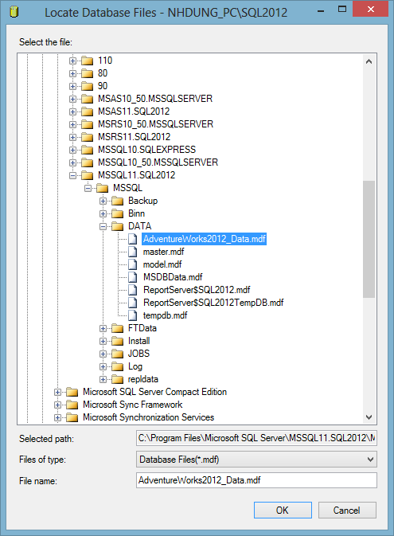
Figure 1.9 - Locate Database Files window
The Attach Databases dialog box shows the files with the AdventureWorks2012 database as shown in Figure 1.10.
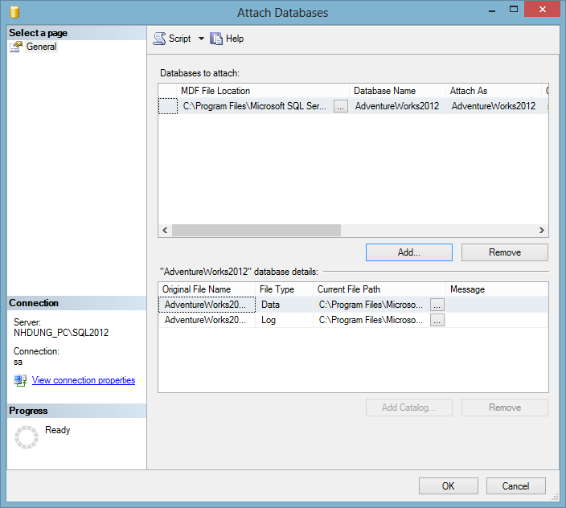
Figure 1.10 - Files of AdventureWorks2012 database
- Click OK to attach the database
The AdventureWorks2012 database is now attached to SQL Server and can be viewed in the Object Explorer window as shown in Figure 1.11
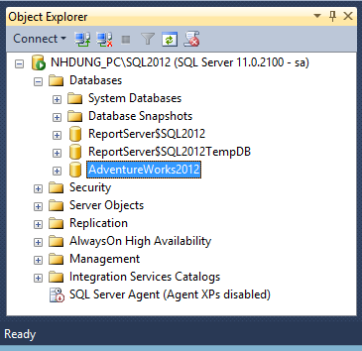
Figure 1.11 - AdventureWorks2012 Database
Launch Query Designer tool
Query Designer is a visual tool that is used to design DML statements. The steps to launch Query Designer tool and design statements are given below:
- Open Query Editor.
- Click Query → Design Query in Editor from the main menu. The Add Table dialog box is displayed as shown in Figure 1.12.
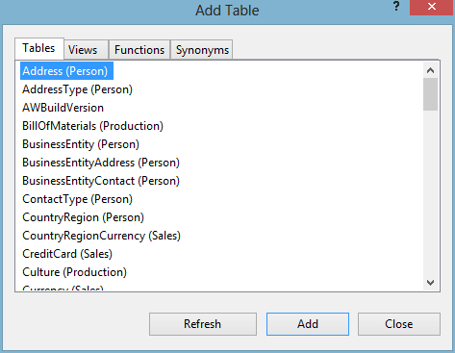
Figure 1.12 - Add table dialog box
- Select the table and click Add button. The table is added to the Query Designer.
- Click Close button. The Query Designer tool is displayed as shown in Figure 1.13.
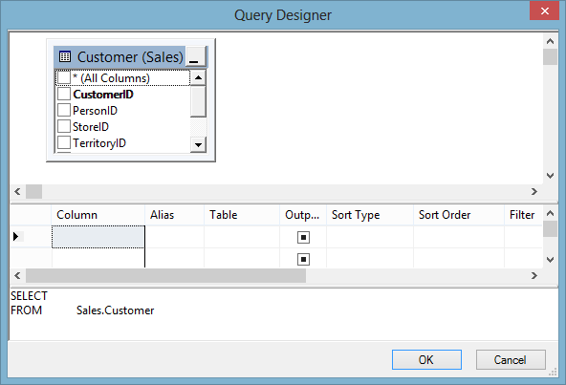
Figure 1.13 - Query Designer Window
The Query Designer window is divided into three panes from top to bottom. First is the Diagram pane, second is the Criteria, and third is the SQL pane.
- Select the checkboxes (table columns) from the Diagram pane. The Criteria and SQL panes will be updated with the required details as shown in Figure 1.14.
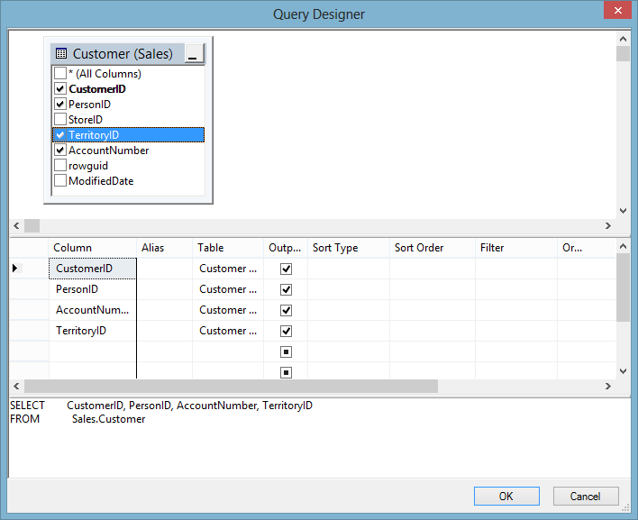
Figure 1.14 - Query Designer with table details
- Click OK. The Query pane will be updated with the SQl query statement.
Part II - 30 Minutes
- Modify Part I exercise 2 to detach the AdventureWork2012 database from SQL Server. After that, attach it again.
Hints:
Right click on the database. Select Tasks → Detach option.
- Use the Object Explorer to backup and restore database.
Hints:
Right click on the database. Select Tasks → Backup or Restore option.

Do It Yourself
    - Use the Object Explorer to create a filter. The filter should display all the tables from the Production schema of AdventureWorks2012 database.
    - Use the Query Editor to execute a query. Ensure that a connection to a new server instance is established. The, from the AdventureWorks2012 database, add the tables namely Product and ProductDocument to Query Designer. To execute a query, select the columns namely, ProductID, Name, ProductNumber from Product table, and DocumentID, ModifiedDate from ProductDocument table and execute the query.

